**NOAA Ship THOMAS JEFFERSON Procedure Document**

Procedure:

**Line Spacing 101**

Creation Date:

**07-18-2020**

Revision Date: 4-14-2021

Software used: NA

Procedure Number:

**TBD**

Approved:

**TBD**

# Overview and Scope

How to calculate line spacing

# 2. Procedure Inputs and Outputs

Inputs: Least depth, swath width, draft, and range scale.

Outputs: line spacing

# Procedure

**SIDE SCAN LINES**

For Side Scan, make polygons to group together like depths

1. Line Spacing= 1.6 x Range Scale (RS)
2. Towfish height range = 8-20% Range Scale (RS)

|  |  |  |
| --- | --- | --- |
| Range Scale (m) | height range (m) | Line Spacing (m) |
| 100 | 8-20 | 160 |
| 75 | 6-15 | 120 |
| 50 | 4-10 | 80 |
| 25 | 2-5 | 40 |

**MBES LINES**

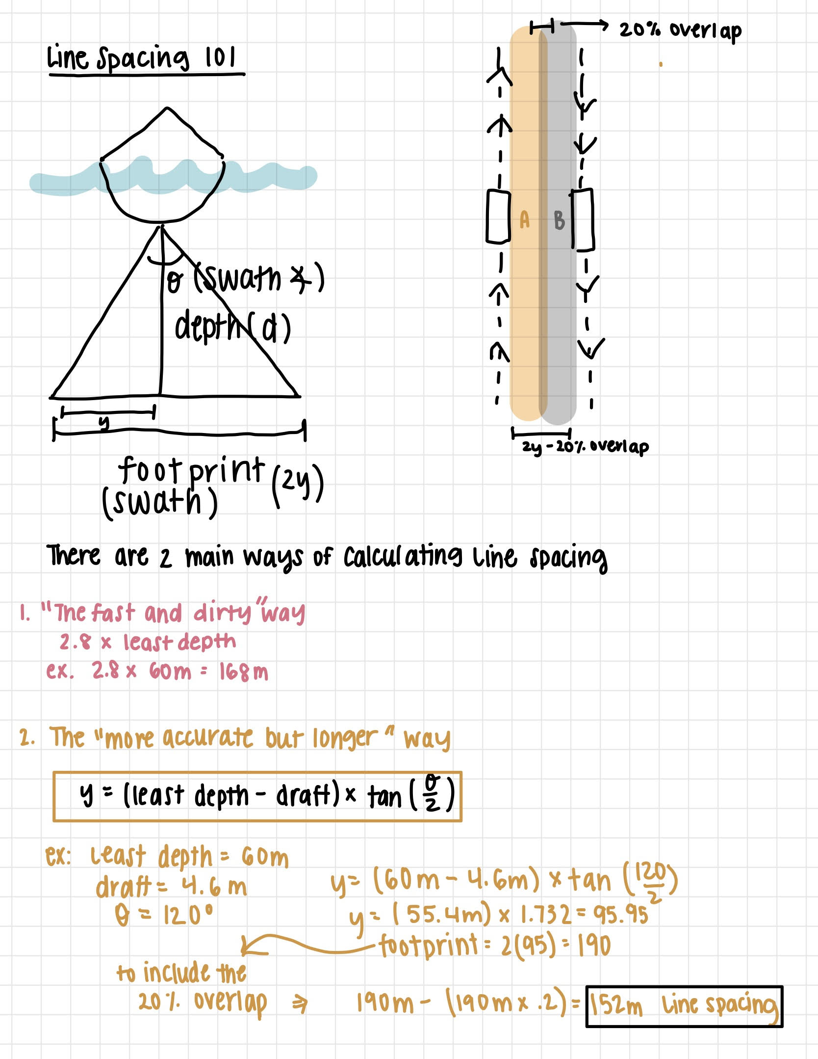

# 4. References